# A PROJECT ON

**“Grocery Management System”**

SUBMITTED IN

PARTIAL FULFILLMENT OF THE REQUIREMENT

FOR THE COURSE OF

DIPLOMA IN ADVANCED COMPUTING FROM CDAC



#### SUNBEAM INSTITUTE OF INFORMATION TECHNOLOGY

Hinjawadi

**SUBMITTED BY:**

1. Milind Shete (63074)
2. Kunal Salunke (62952)
3. Praveen Vaware (62792)
4. Pratik Satpute (62758)

**UNDER THE GUIDENCE OF:**

Mrs. Lalita Shinde

Faculty Member

Sunbeam Institute of Information Technology, PUNE.

ACKNOWLEDGEMENT

A project usually falls short of its expectation unless aided and guided by the right persons at the right time. We avail this opportunity to express our deep sense of gratitude towards Mr. Nitin Kudale (Center Coordinator, SIIT, Pune) and Mr. Yogesh Kolhe (Course Coordinator, SIIT ,Pune) .

We are deeply indebted and grateful to them for their guidance, encouragement and deep concern for our project. Without their critical evaluation and suggestions at every stage of the project, this project could never have reached its present form.

Last but not the least we thank the entire faculty and the staff members of Sunbeam Institute of Information Technology, Pune for their support.

Milind Shete (63074)

Kunal Salunke (62952)

Praveen Vaware (62792)

Pratik Satpute (62758)

PGDAC March, 2022 Batch,

SIIT Pune



**CERTIFICATE**

This is to certify that the project work under the title ‘Grocery Management System’ is done by Milind Shete, Kunal Salunke, Praveen Vaware, Pratik Satpute in partial fulfillment of the requirement for award of Diploma in Advanced Computing Course.

**Mrs. Lalita Shinde Mr.Yogesh Kolhe**

**Project Guide Course Co-Coordinator**

Date: 29/09/2022

# INTRODUCTION TO PROJECT

Grocery is a part of everyone’s day to day life. There is basic 5 needs of each human being like food, shelter, clothes, education and health. But the food is most essential out of these 5 needs. Grocery’s major part contains food. And here we found the scope to make this system.

We have given thought to this grocery management system according to Indian market. In India due to heavy traffic in major cities, pollution, time concern, etc. many people prefer to buy online. Not only grocery but also nowadays people are buying clothes online which we used to think that we cannot buy without trial. Grocery for Indian families is fixed for month; it doesn’t need any trial or anything else. There is so many checking has been already done by FSSAI (Food Safety and Standards Authority of India). So, Customer generally go to the supermarket or any grocery shop just to buy monthly grocery. The purpose of this system is to save the time of customer and also reduce the road traffic as well as it will reduce pollution.

In this system customer can place order online for their groceries. Customers will get their delivery at door step. Also, customer will get suggestions for grocery buying for next buying. It is basically grocery shopping website like other shopping websites like amazon, flipkart etc. But its focus is on only grocery. This idea has very huge market because it is daily necessity for survival as well as for comfortable lifestyle. People are unable to find time to household works like buying grocery. So, by this platform we provide grocery. This system can be used to search for all grocery and fresh vegetables which are available in the market.

Over all this system is very useful from customer perspective as well as seller perspective. This will save both time and money. After COVID-19 pandemic we realized that majority of the household work or even office work can be done online. By saving this time we can do what we love to do.

**2. REQUIREMENTS**

**2.1 FUNCTIONAL REQUIREMENTS**

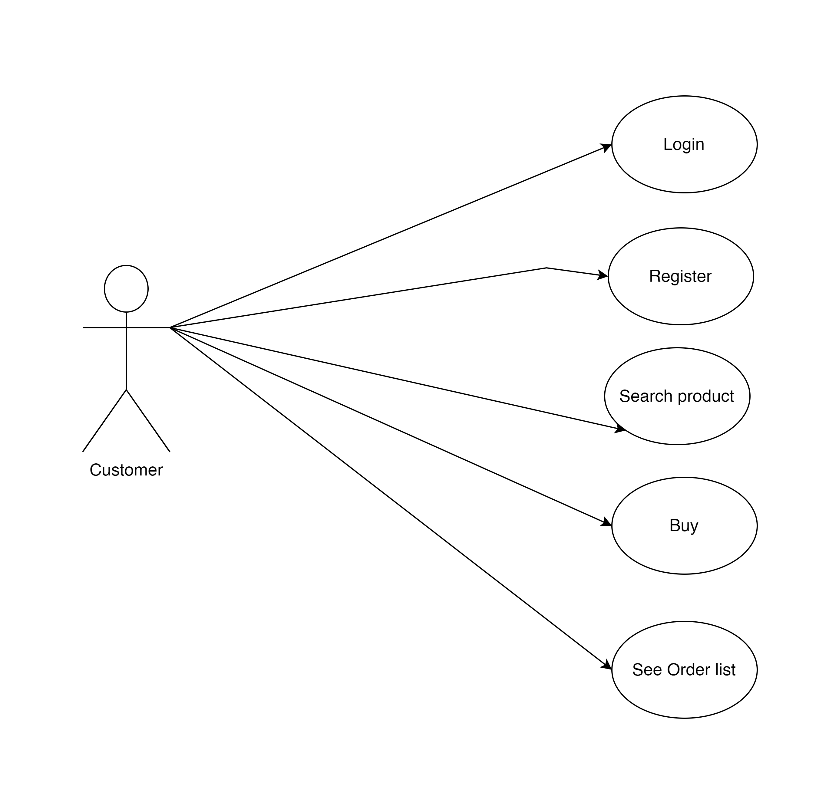

**2.1 Customer Account**

The customer, who will henceforth be called the ‘user’, will be presented with 3 choices by the Grocery Management system, as the first step in the interaction between them. A user can choose one of these and his choice would be governed by whether he is a guest or a registered user and whether he wants to check the availability of products or also buy them. The terms ‘registered user’ and ‘guest’ are described below.

A user who has bought the products earlier would have been given a user id and a password. This ‘personal information’ would be henceforth referred to as ‘profile’. Such a user with a profile in DB-user shall be called a ‘registered user’. A registered user will be able to check the availability of products as well as buy a product by logging into the system.

A new user, on the other hand, would either have to register himself with the system by providing personal information. The new user becomes a registered user.

A guest can only check the products and cannot add products in to cart directly.

GMS shall present the user with an option to exit from the system at any time during the following processes.

**2.2 Registration and creation of user profile**

The system shall require a user to register, in order to carry out any transactions with it except for checking out products. It will ask the user for the following information at the least –first name, last name, email address, address, pin code, city, state, phone number, and password.

* 1. **Quick Search**

Here we provided Quick Search facility for any user to search particular product without login into account .This will provide user an option for searching product.

After entering product name in the search bar, it compares the names of available products with the name entered by user. And the products with the matching names will be displayed.

* 1. **Cart**

Products can be added in to cart by two ways

1. From Home page user will be able to select the desired category. After clicking on the category user will be able to see all the products of selected category. After this user will be able to add any desired products by clicking on “add to cart”.
2. User can find products by searching in the search bar. After entering product name in the search bar, it compares the names of available products with the name entered by user. And the products with the matching names will be displayed. After this user will be able to add any desired products by clicking on “add to cart”.

After adding products in the cart user will be able to see all the products added under the cart section. Here user can set the quantity of selected products. Also user can delete unwanted products from the cart. User can see total cart value.

**2.5 Checkout**

In checkout page, the system shall allow a user to view all information about cart and total cart amount. Here user will be able to choose a payment option from available payment methods.

**Admin Account**

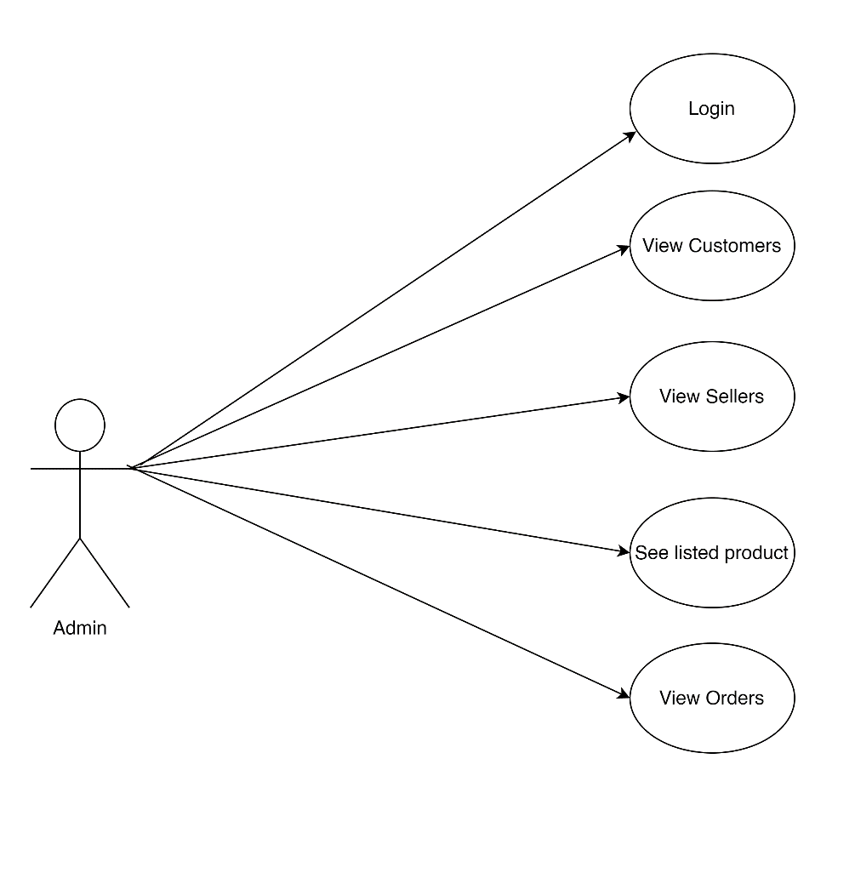

Admin should be able to login, View customer information, View Seller information, View Product list, View Order list. Admin should also be able edit delete customer, seller and product.

**Seller Account**

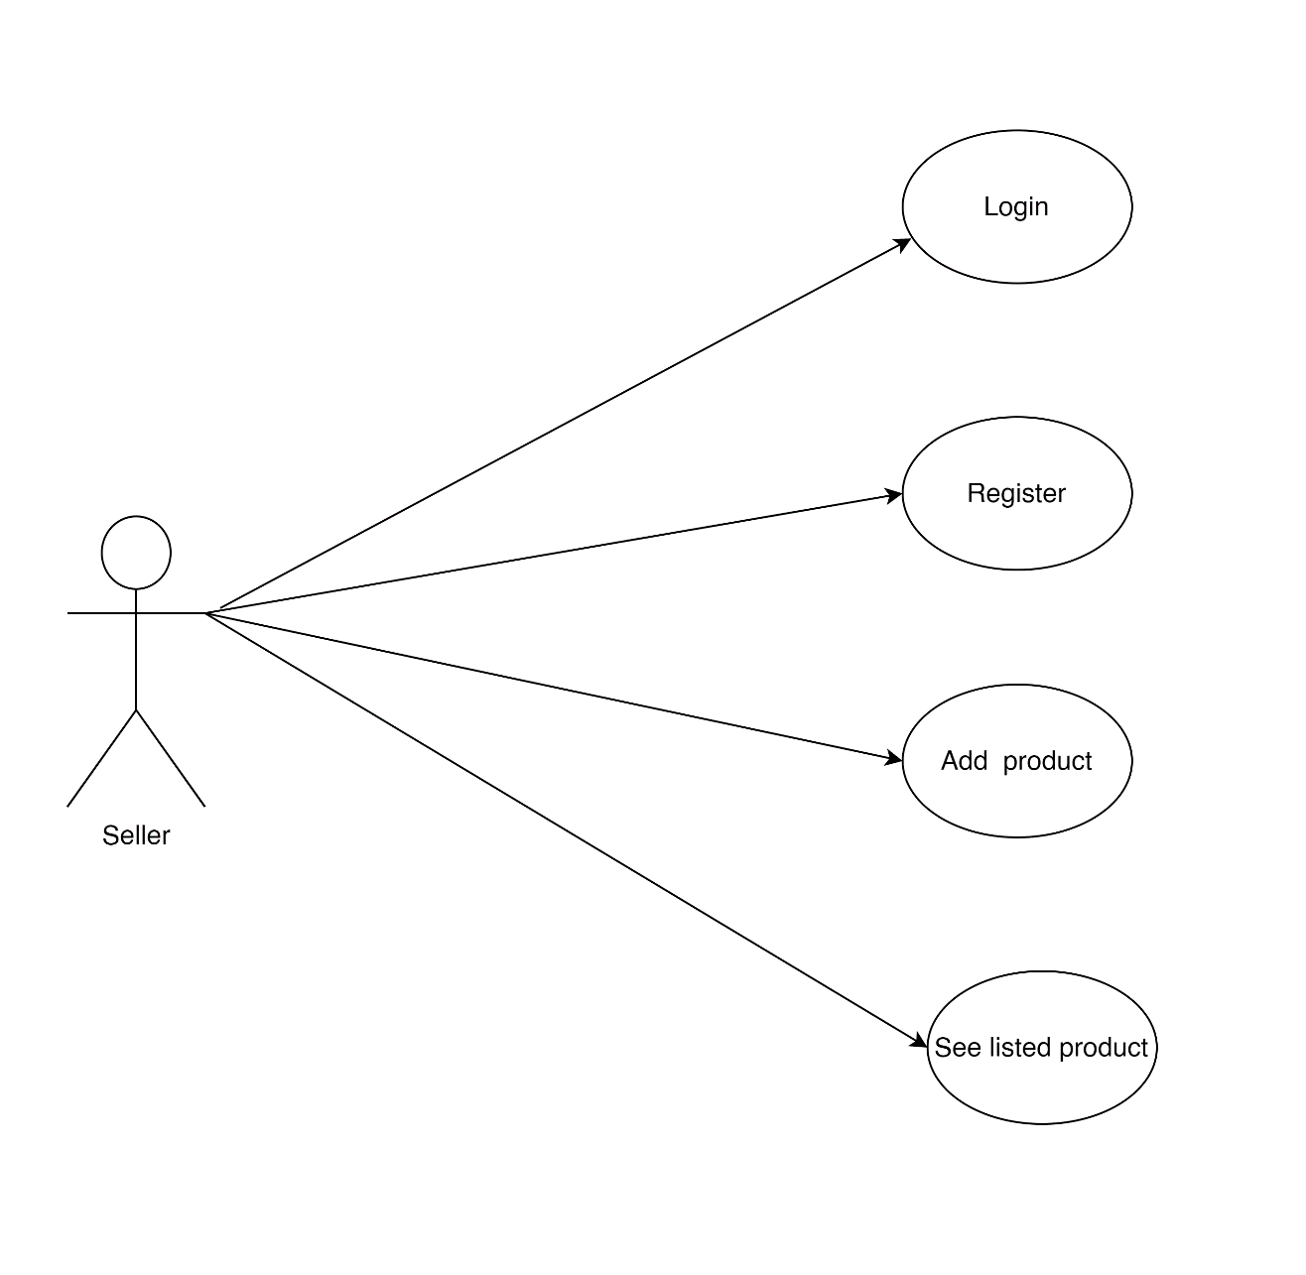

Seller should be able to login, Sign Up, View his Product list, View his Order list. Seller should also be able edit and delete products.

* 1. **NON FUNCTIONAL REQUIREMENTS**

**2.2.1 Interface**

Go to Appendix B for user interfaces

**2.2.2 Performance**

* **Number of Concurrent Users:**

GMS shall be able to handle at least 1000 transactions per second

**2.2.3 Constraint**

GMS shall be able to handle at least 1000 transactions/inquiries per second

**2.2.4 Other Requirements:**

* **Hardware Interfaces**

The GMS is expected to function on Intel Pentium 4 Processor equivalent or above, 2 GB RAM, 20 GB HDD.

* **Software Interfaces**

The GMS shall work on MS Windows operating systems family (Windows 8 or later). It configures to work with MySQL database. This System works on Apache Tomcat server. It uses browser IE 5.0 & above. It uses IIS 5.0 server.

**3. DESIGN**

**3.1 Database Design**

The following table structures depict the database design.

# Table 1: Customer Info :

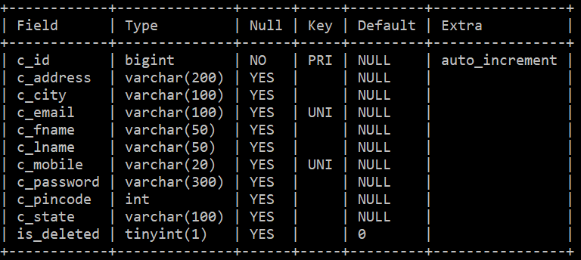

## **Table 2: Seller Info:**

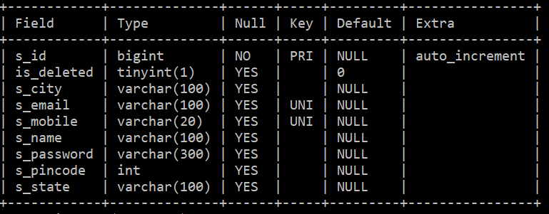

# Table 3: Category Info:

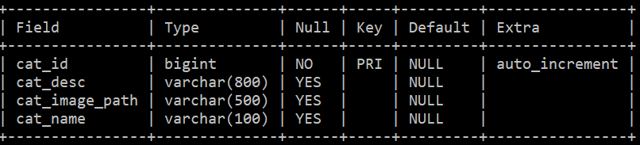

### Table 4: Product Info :

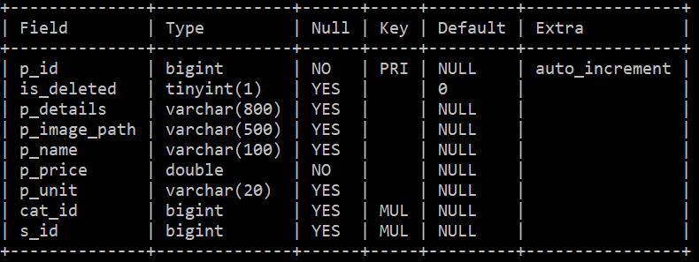

**Table 5: Orders Info:**

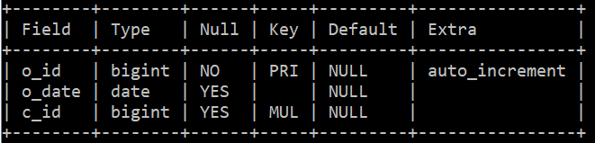

### Table 6: Order Details

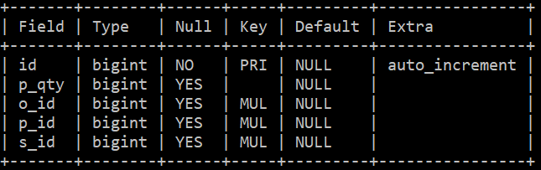

### Table 7: Contact US

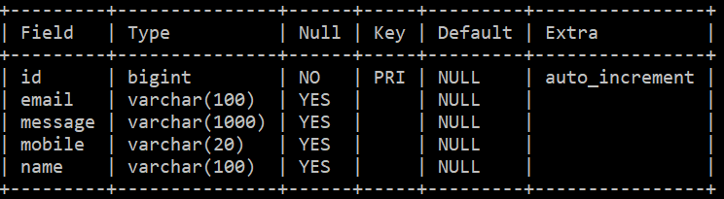

**E-R Diagram, Dataflow diagram and Class Diagram:**

Go to Appendix A

**4. CODING STANDARDS IMPLEMENTED**

### Naming and Capitalization

Below summarizes the naming recommendations for identifiers in Pascal casing is used mainly (i.e. capitalize first letter of each word) with camel casing (capitalize each word except for the first one) being used in certain circumstances.

|  |  |  |  |
| --- | --- | --- | --- |
| **Identifier** | **Case** | **Examples** | **Additional Notes** |
| Class | Pascal | Customer, Seller, etc. | Class names should be based on "objects" or "real things" and should generally be **nouns**. No ‘_’ signs allowed. Do not use type prefixes like ‘C’ for class. |
| Method | Camel | saveProduct, addSeller, | Methods should use **verbs** or verb phrases. |
| Parameter | Camel | isDeleted | Use descriptive parameter names. Parameter names should be descriptive enough that the name of the parameter and its type can be used to determine its meaning in most scenarios. |
| Interface | Pascal with "I" prefix | ICustomerRepository | Do not use the ‘_’ sign |
| Property | Pascal |  | Use a noun or noun phrase to name properties. |
| Associated private member variable | _camelCase |  | Use underscore camel casing for the private member variables |
| Exception Class | Pascal with "Exception" suffix | ResourceNotFoundException, |  |

### Comments

* Comment each type, each non-public type member, and each region declaration.
* Use end-line comments only on variable declaration lines. End-line comments are comments that follow code on a single line.
* Separate comments from comment delimiters (apostrophe) or // with one space.
* Begin the comment text with an uppercase letter.
* End the comment with a period.
* Explain the code; do not repeat it.

**5. TEST REPORT**

**Another group called Linux did the testing and the report of the testing is given hereunder.**

**GENERAL TESTING:**

|  |  |  |  |  |
| --- | --- | --- | --- | --- |
| **SR-NO** | **TEST CASE** | **EXPECTED RESULT** | **ACTUAL RESULT** | **ERROR MESSAGE** |
| 1 | Sign Up Page | Redirected to Next page | OK | Nothing |
| 2 | Login Page | Pop-up will come | Ok | Please enter username and password again . |
| 3 | Home page | Fetching All product’s category | Ok | Nothing |
| 4 | Quick search product | Gives all matching products | Ok | Nothing |
| 5 | Add to Cart | Product added to cart | Ok | Nothing |
| 6 | Checking login or not | User is logged in or not | Ok | Nothing |
| 7 | Cart Total Amount | Gives total cart amount | Ok | Nothing |
| 8 | Go to payment page | Payment page | Ok | Nothing |
| 9 | Admin /Seller login page | Redirected to home page of admin/seller | Ok | Nothing |
| 10 | Seller details | Gives all the seller details in tabular form | Ok | Nothing |
| 11 | Product details | Gives all the product details in tabular form with edit and delete function | Ok | Nothing |
| 12 | Customer Details | Gives customer details to admin | Ok | Nothing |
|  | **STATIC TESTING** |  |  |  |
| **SR-NO** | **Deviation** | **Program** |  |  |
| 1 | Commenting not followed | All Web Application |  |  |

**6. PROJECT MANAGEMENT RELATED STATISTICS**

|  |  |  |  |
| --- | --- | --- | --- |
| **DATE** | **WORK PERFORMED** | ****SLC Phase**** | **Additional Notes** |
| May 28,2022 | Project Allotment and User Requirements Gathering | Feasibility Study | -- |
| June 10,2022 | Initial SRS Document Validation  And Team Structure Decided | Requirement Analysis  (Elicitation) | The initial SRS was presented to the client to understand his requirements better |
| June 16,2022 | Designing the use-cases, Class Diagram, Collaboration Diagram, E-R Diagram and User Interfaces | Requirement Analysis &  Design Phase | Database Design completed |
| July 5,2022 | Business Logic Component design Started | Design Phase | ---------------------- |
| July 25,2022 | Coding Phase Started | Coding Phase | Folder structure, coding conventions were finalized. |
| SEP 5,2022 | Implementation of Backend for Web Application Started | Coding Phase | Express.js and Spring Boot API development started. |
| SEP 10,2022 | Implementation of Backend completed | Coding Phase | Express.js and Spring Boot Backend API were completed. |
| SEP 12,2022 | Evaluation done for backend API. | Evaluation Phase | -- |
| SEP 15,2022 | Customer login, signup, homepage and search products page were created. | Coding Phase and Unit Testing | -- |
| SEP 17,2022 | Admin pages with API integration was completed. | Coding Phase and Unit Testing | Module Integration was done |
| SEP 19,2022 | Seller pages with API integration was completed. | Testing Phase (Module Testing) | -- |
| SEP 21,2022 | Cart page implemented with the help of redux, checkout page was created. | Testing Phase (Acceptance Testing) | The Project of Other Team was Taken up by the Team for Testing |
| SEP 23,2022 | The Errors Found were removed | Debugging | The Project was complete for submission |
| SEP 24,2022 | Final Submission of Project |  |  |

Appendix A

Entity Relationship Diagram

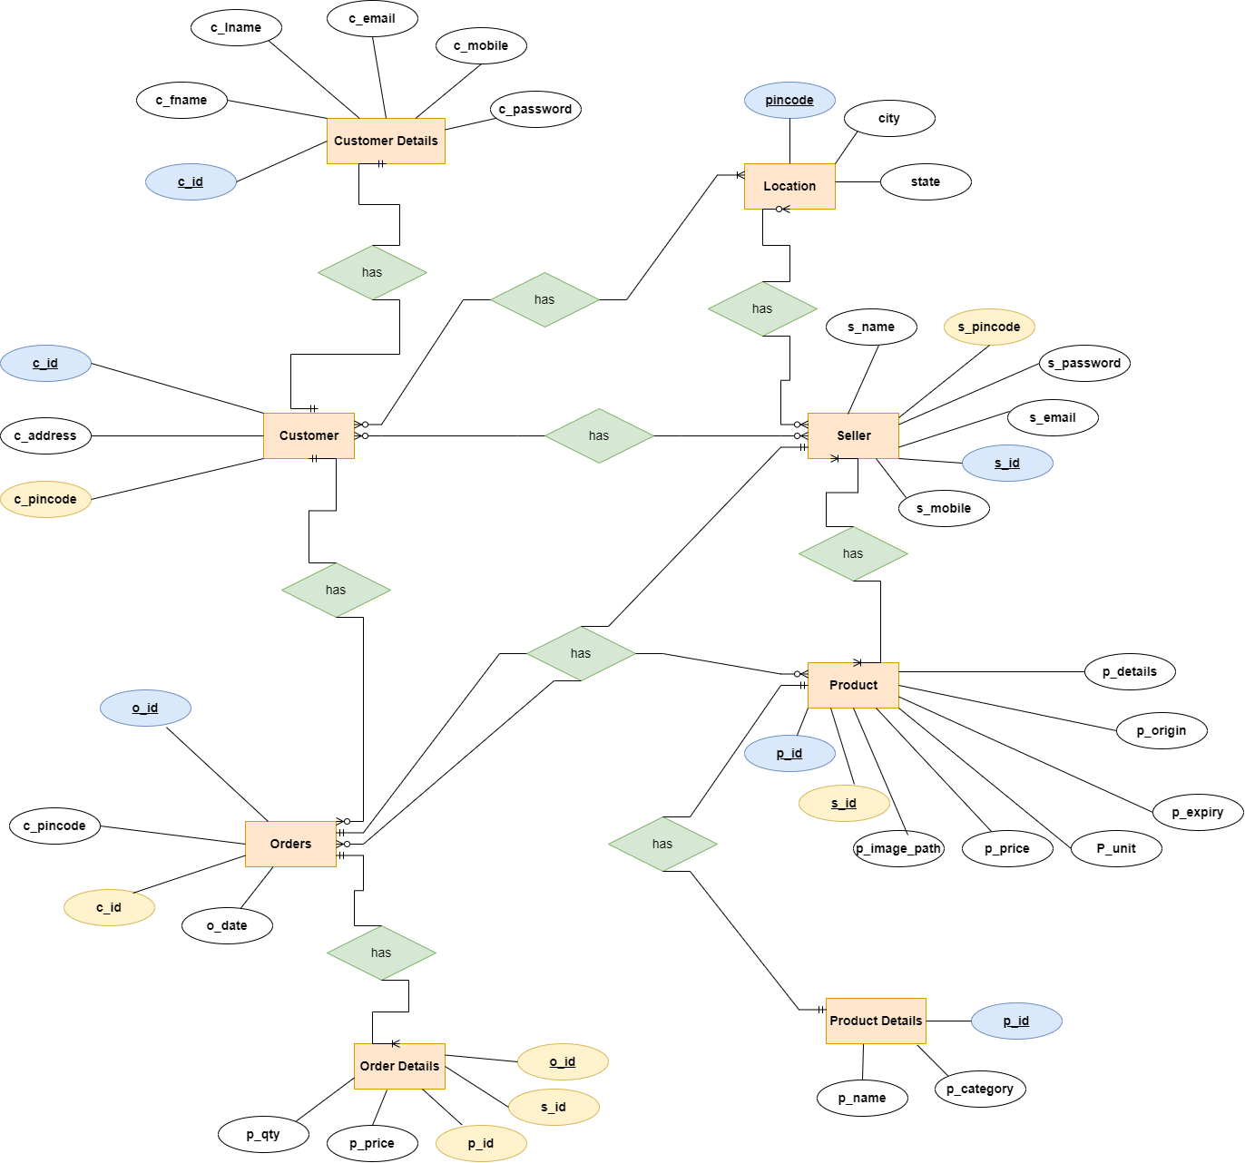

**Use Case Diagram:**

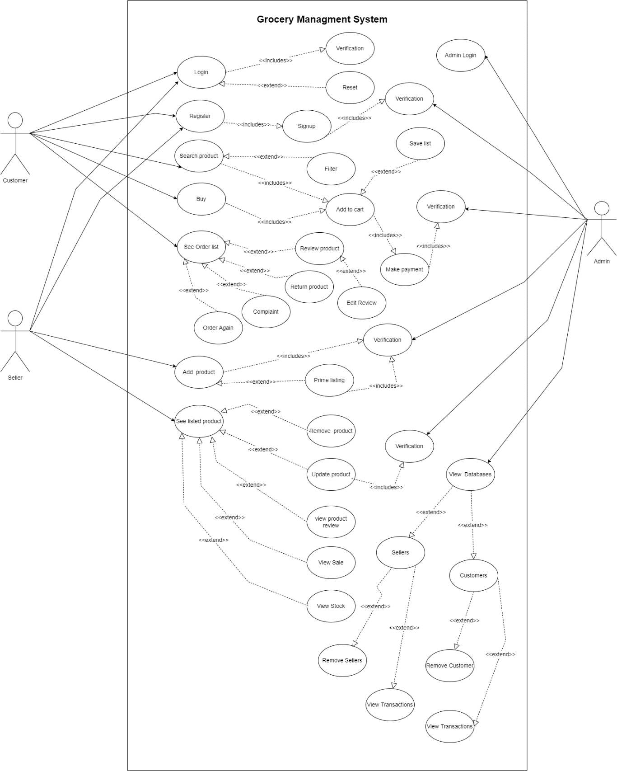

**Class Diagram**

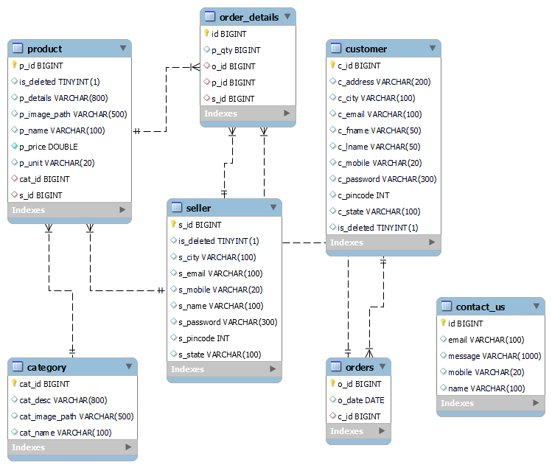

Appendix B

Homepage:

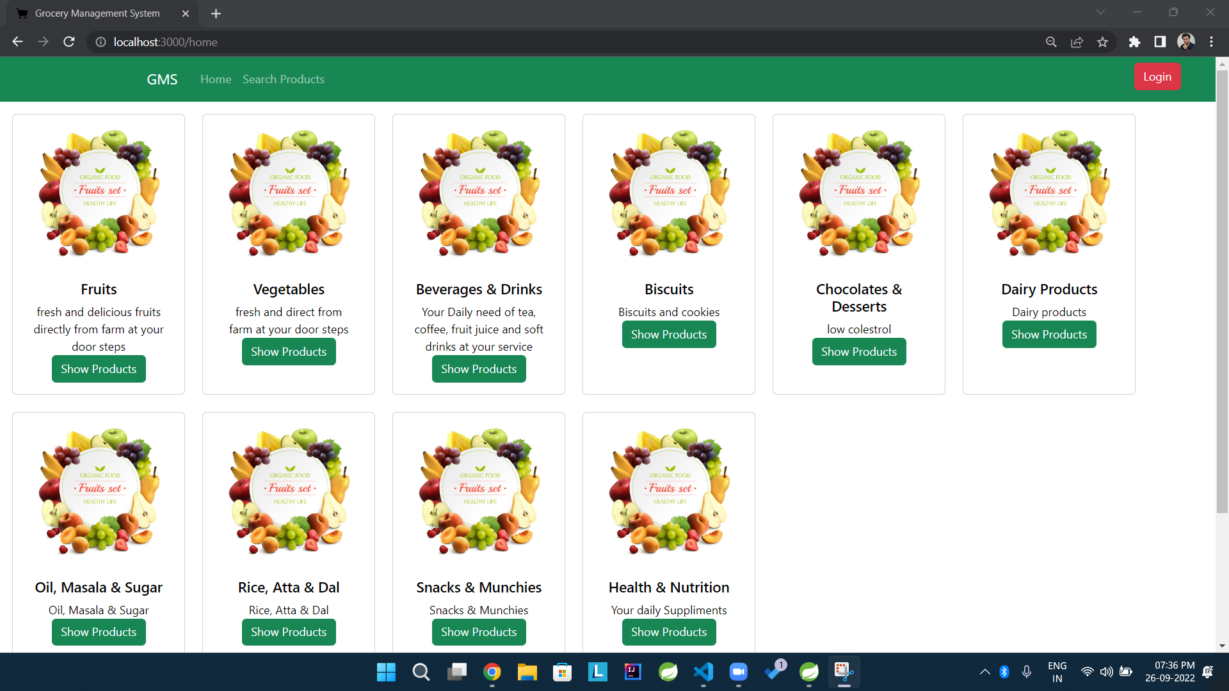

Login Popup:

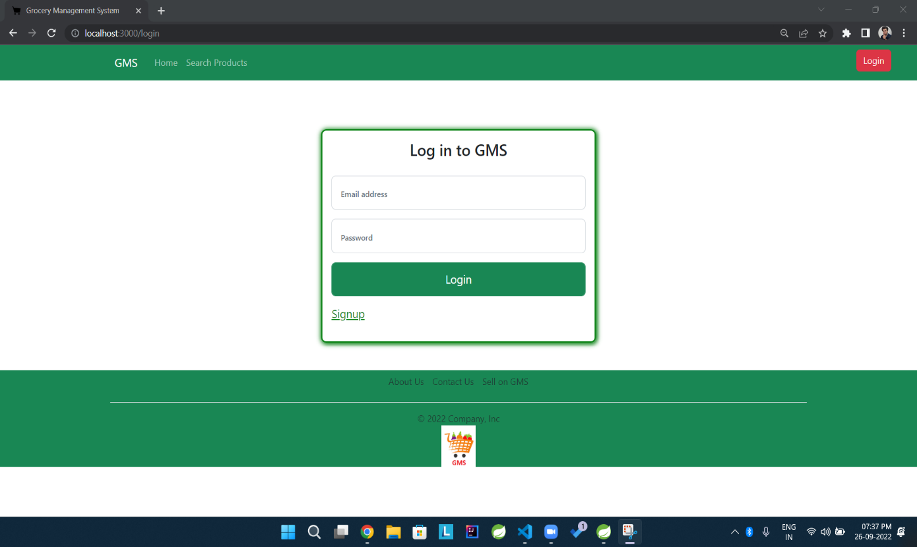

Search Product:

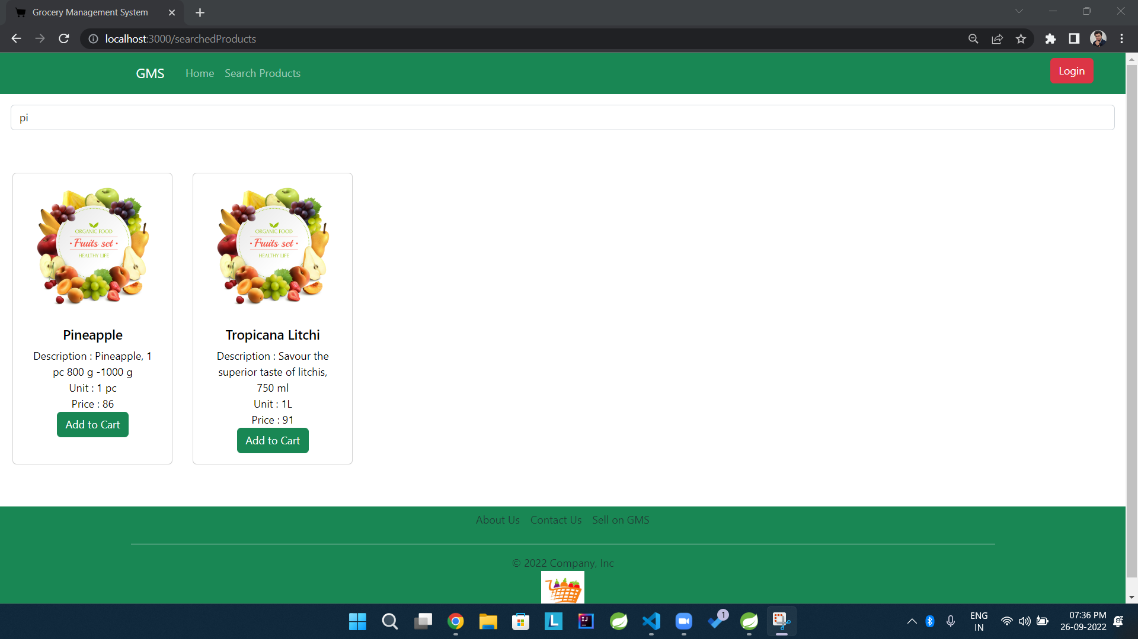

**Customer Sign Up:**

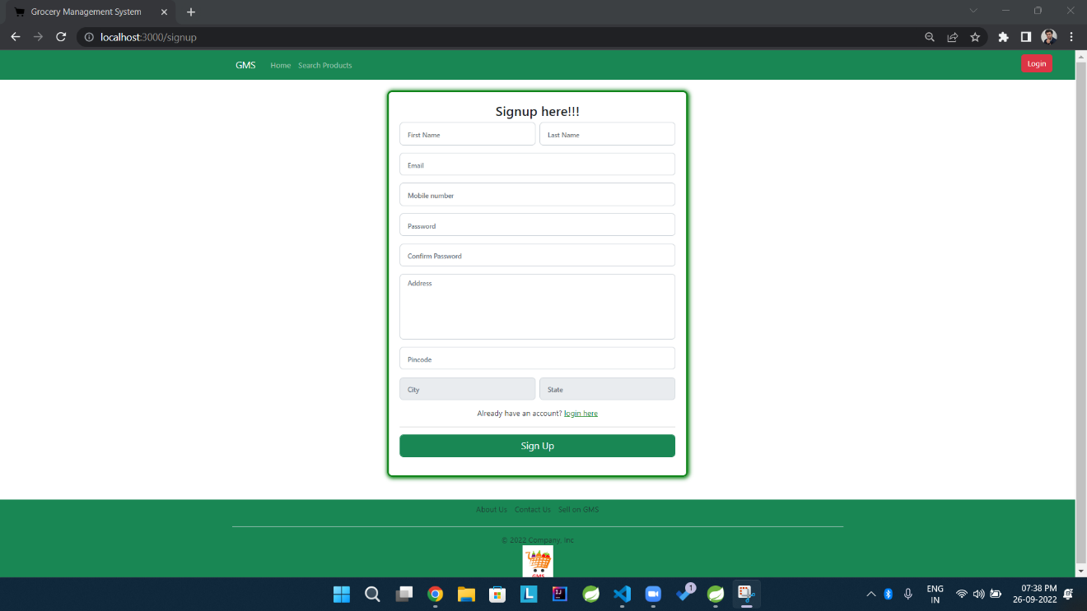

**After Customer Log In:**

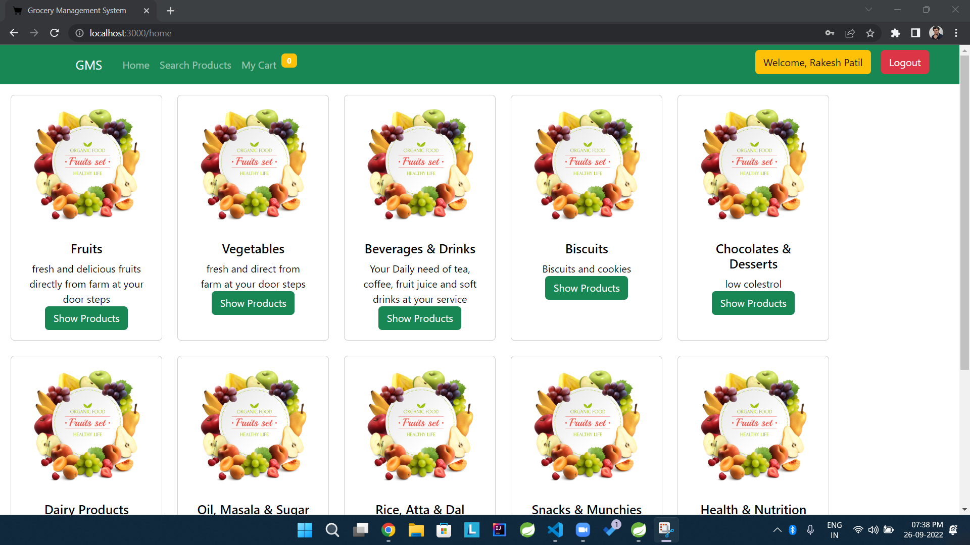

**Cart:**

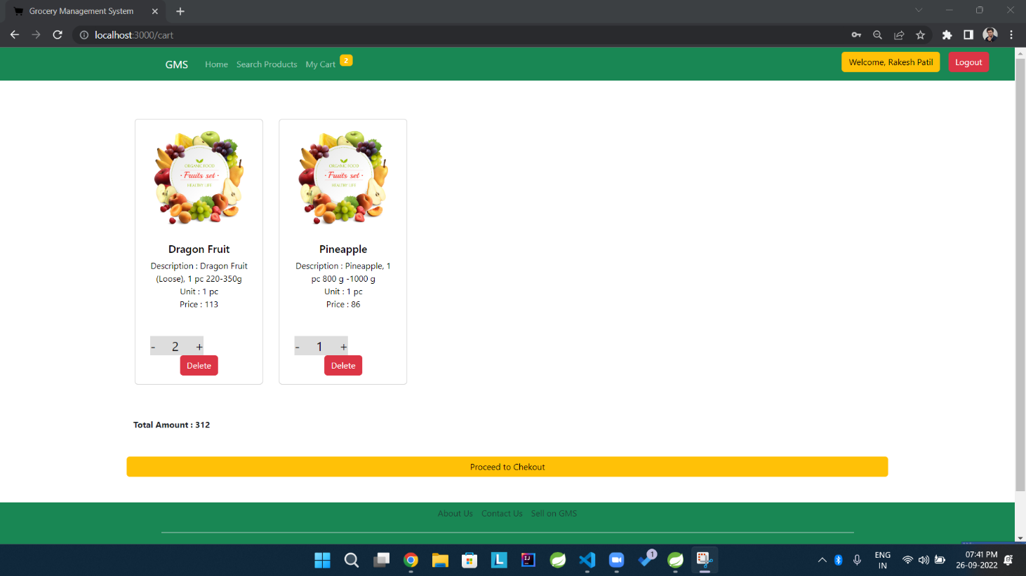

**Payment Page:**

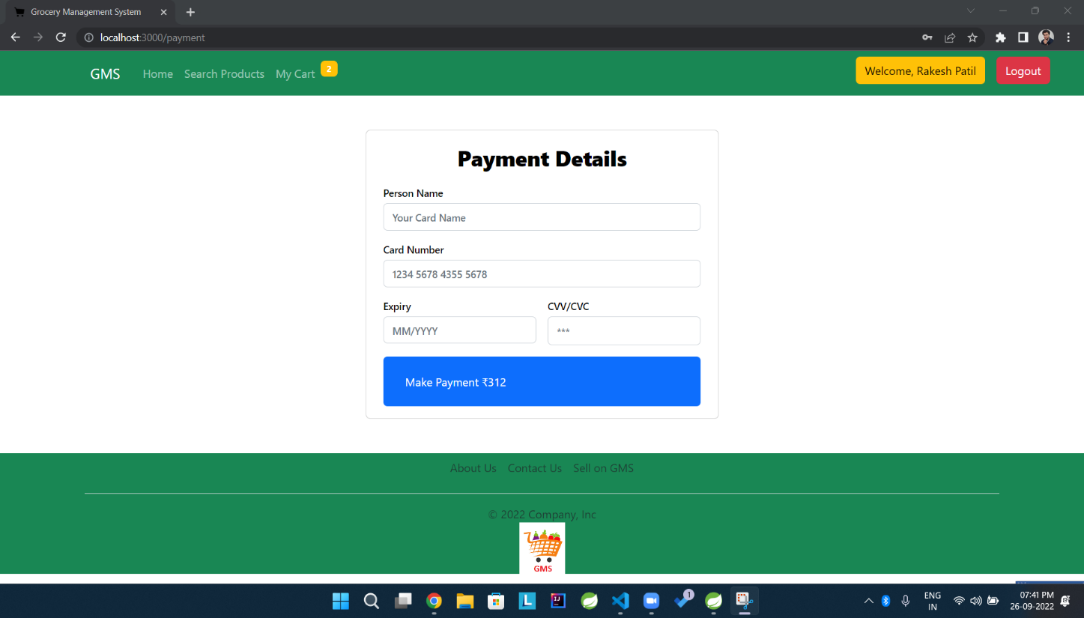

Contact Us:

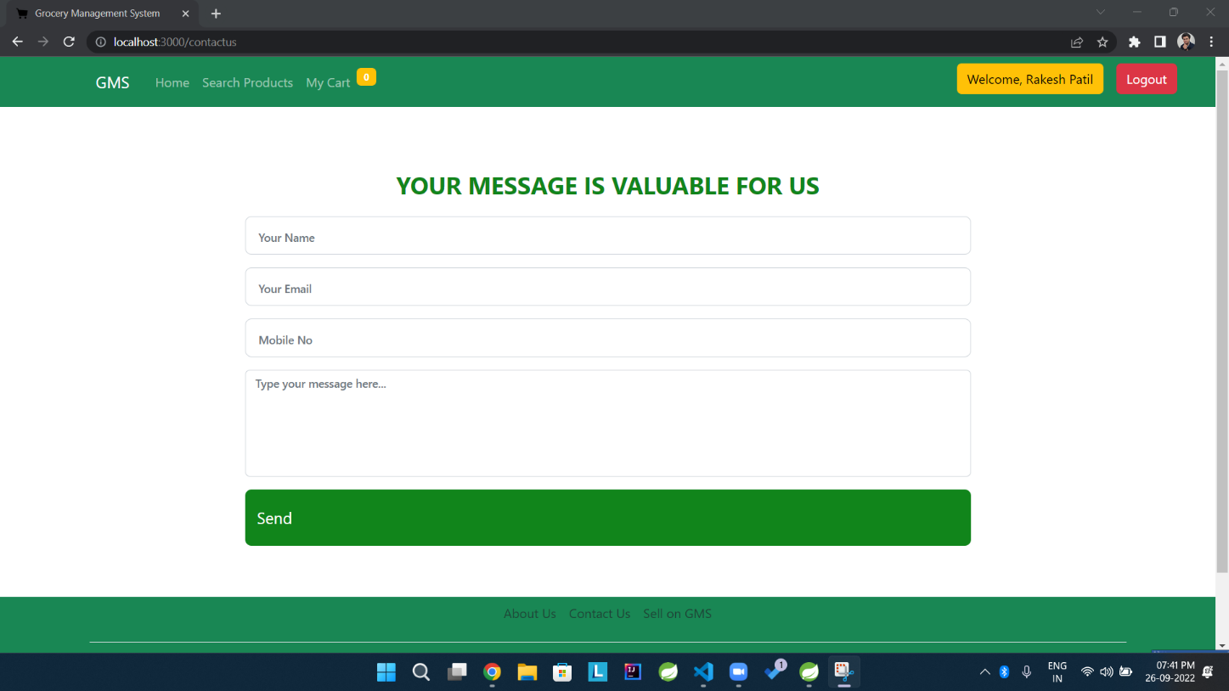

About Us:

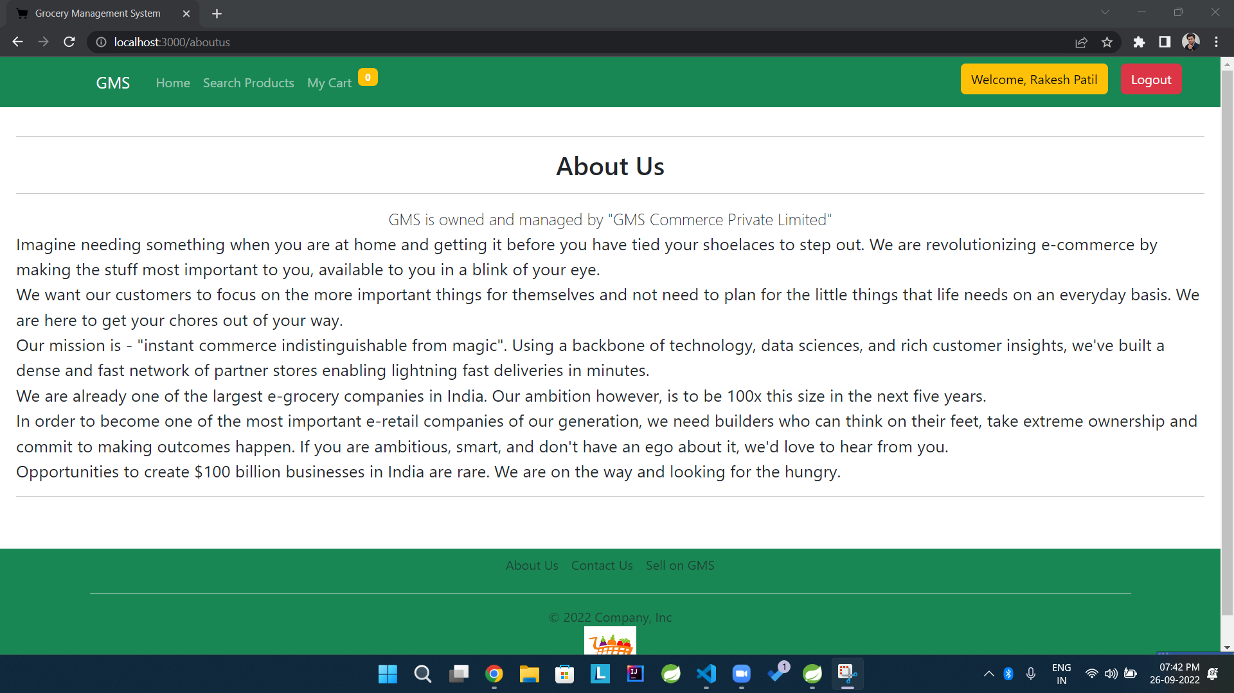

Administrators / Seller Login:

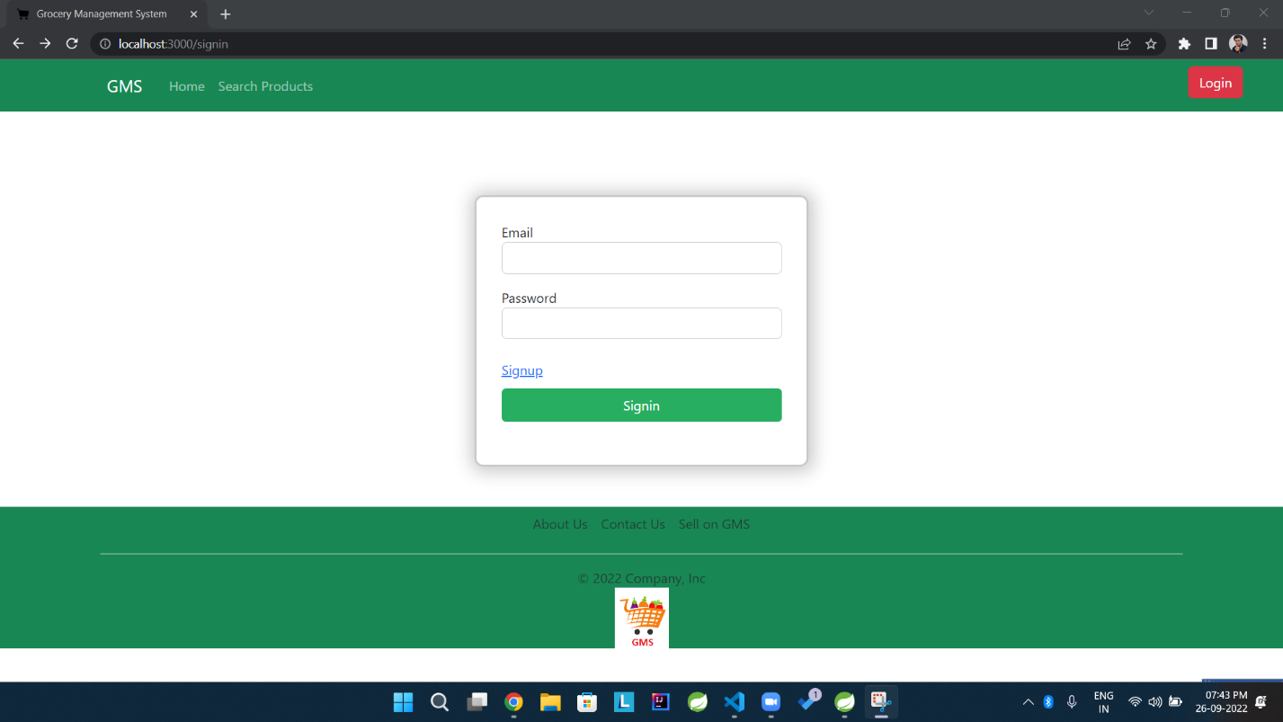

Seller Sign Up:

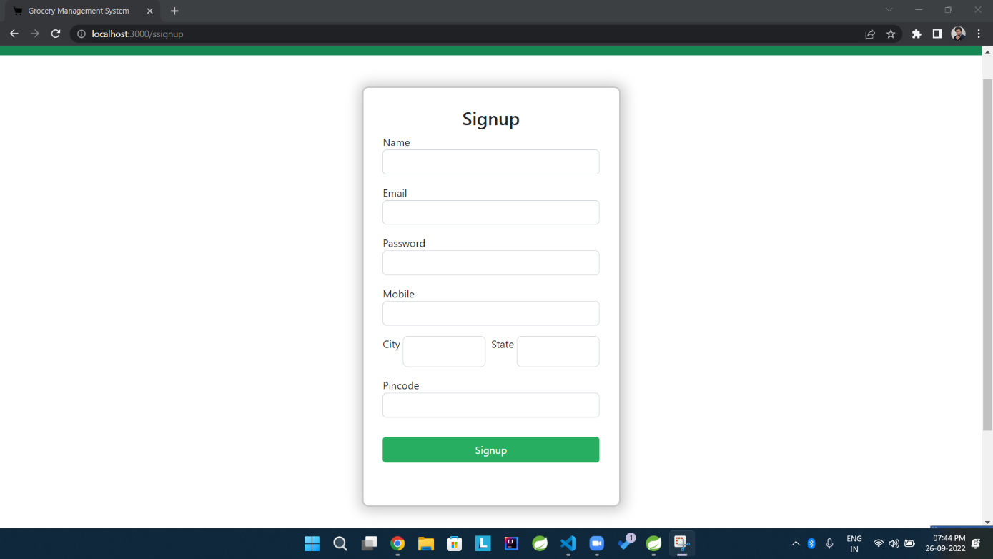

**Admin Page 🡪Seller Details:**

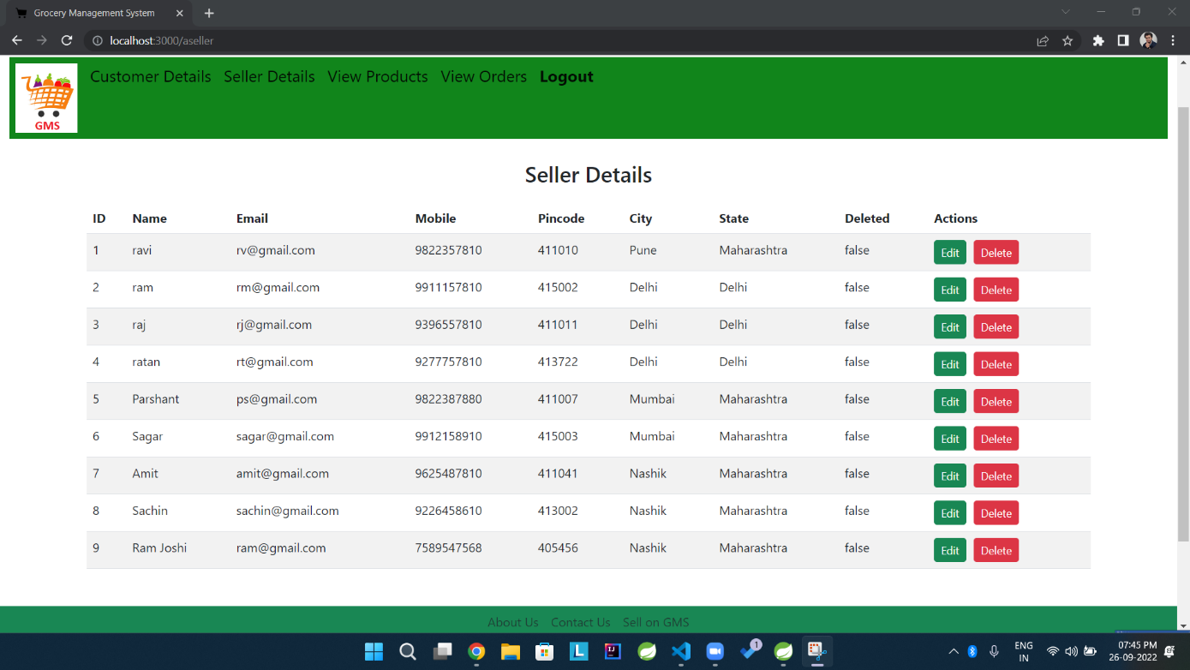

**Admin Page 🡪 Customer Details:**

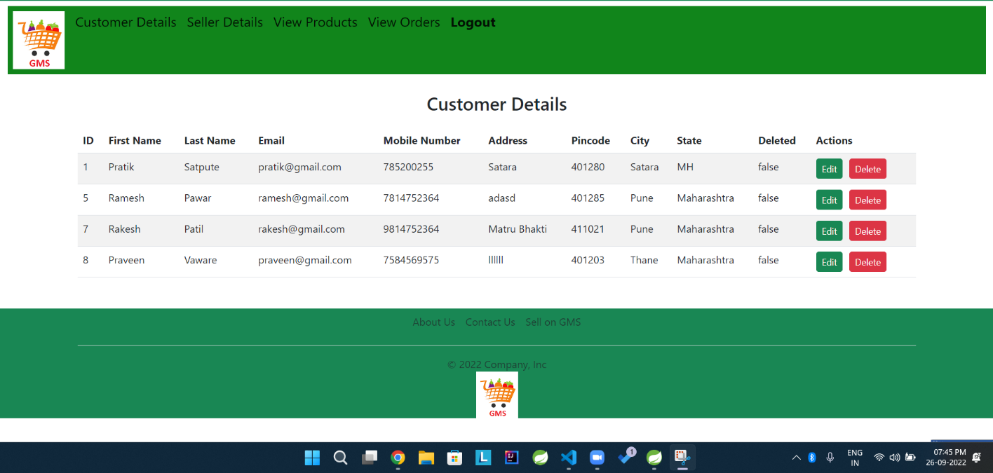

**Admin Page 🡪 Product Details:**

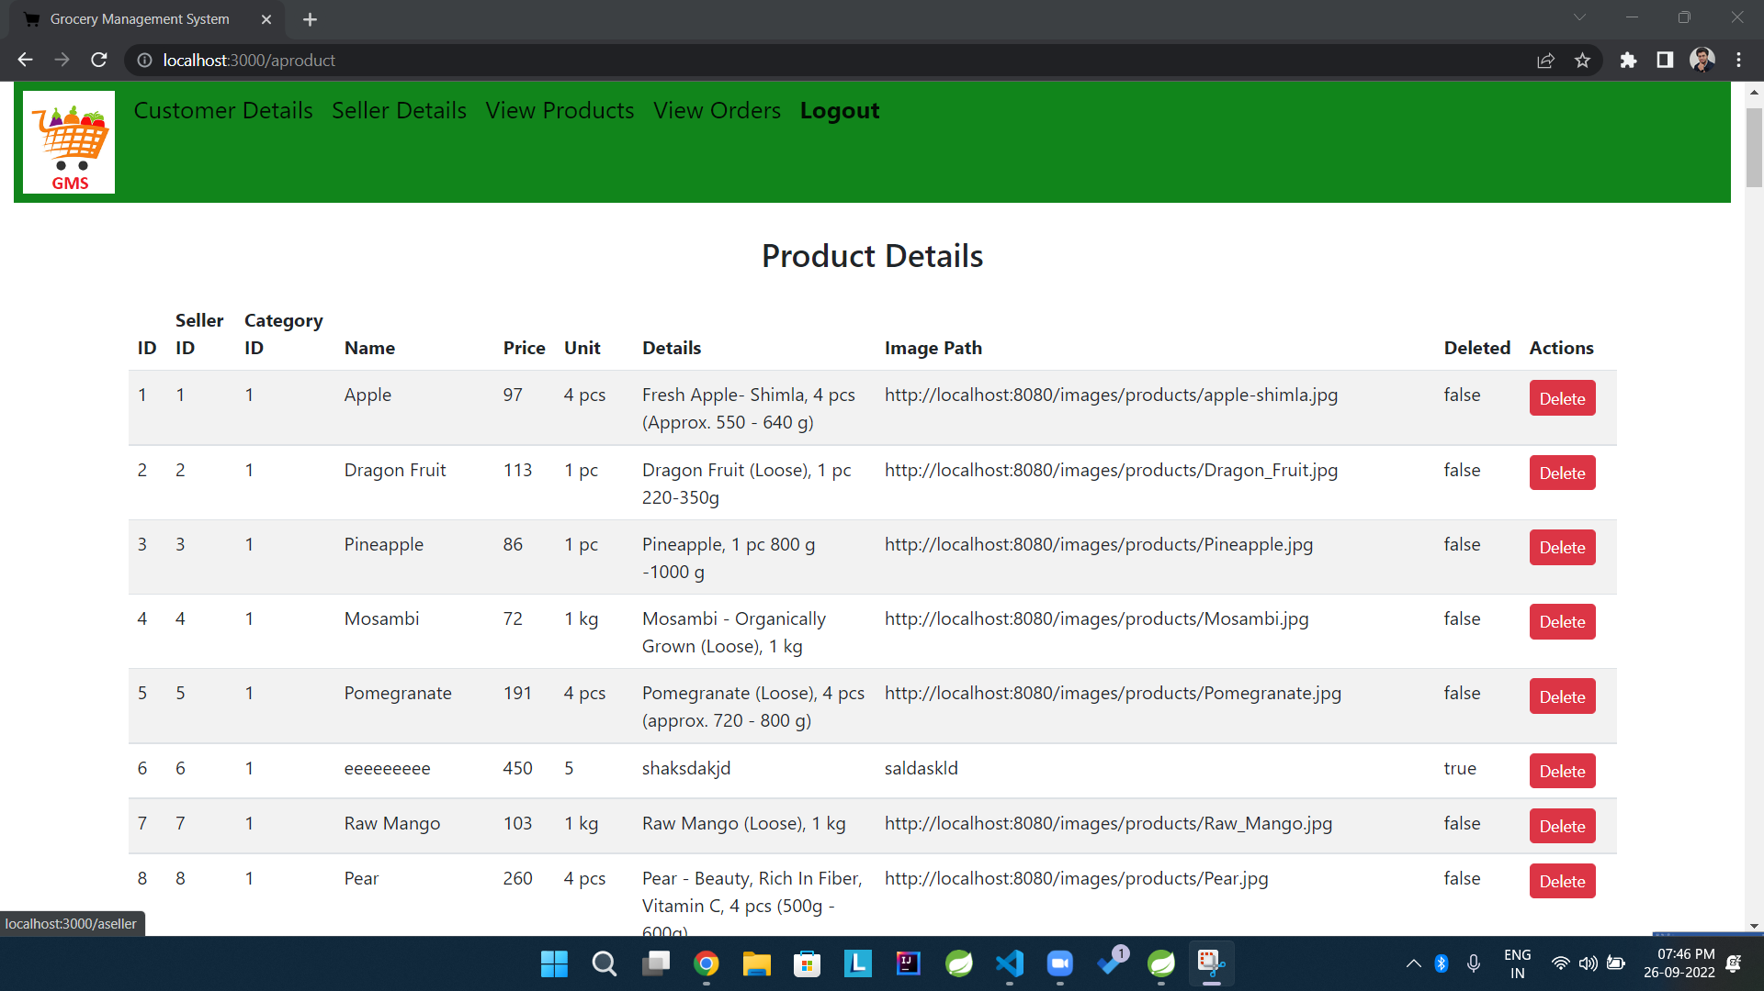

**Seller Page 🡪 Product Details:**

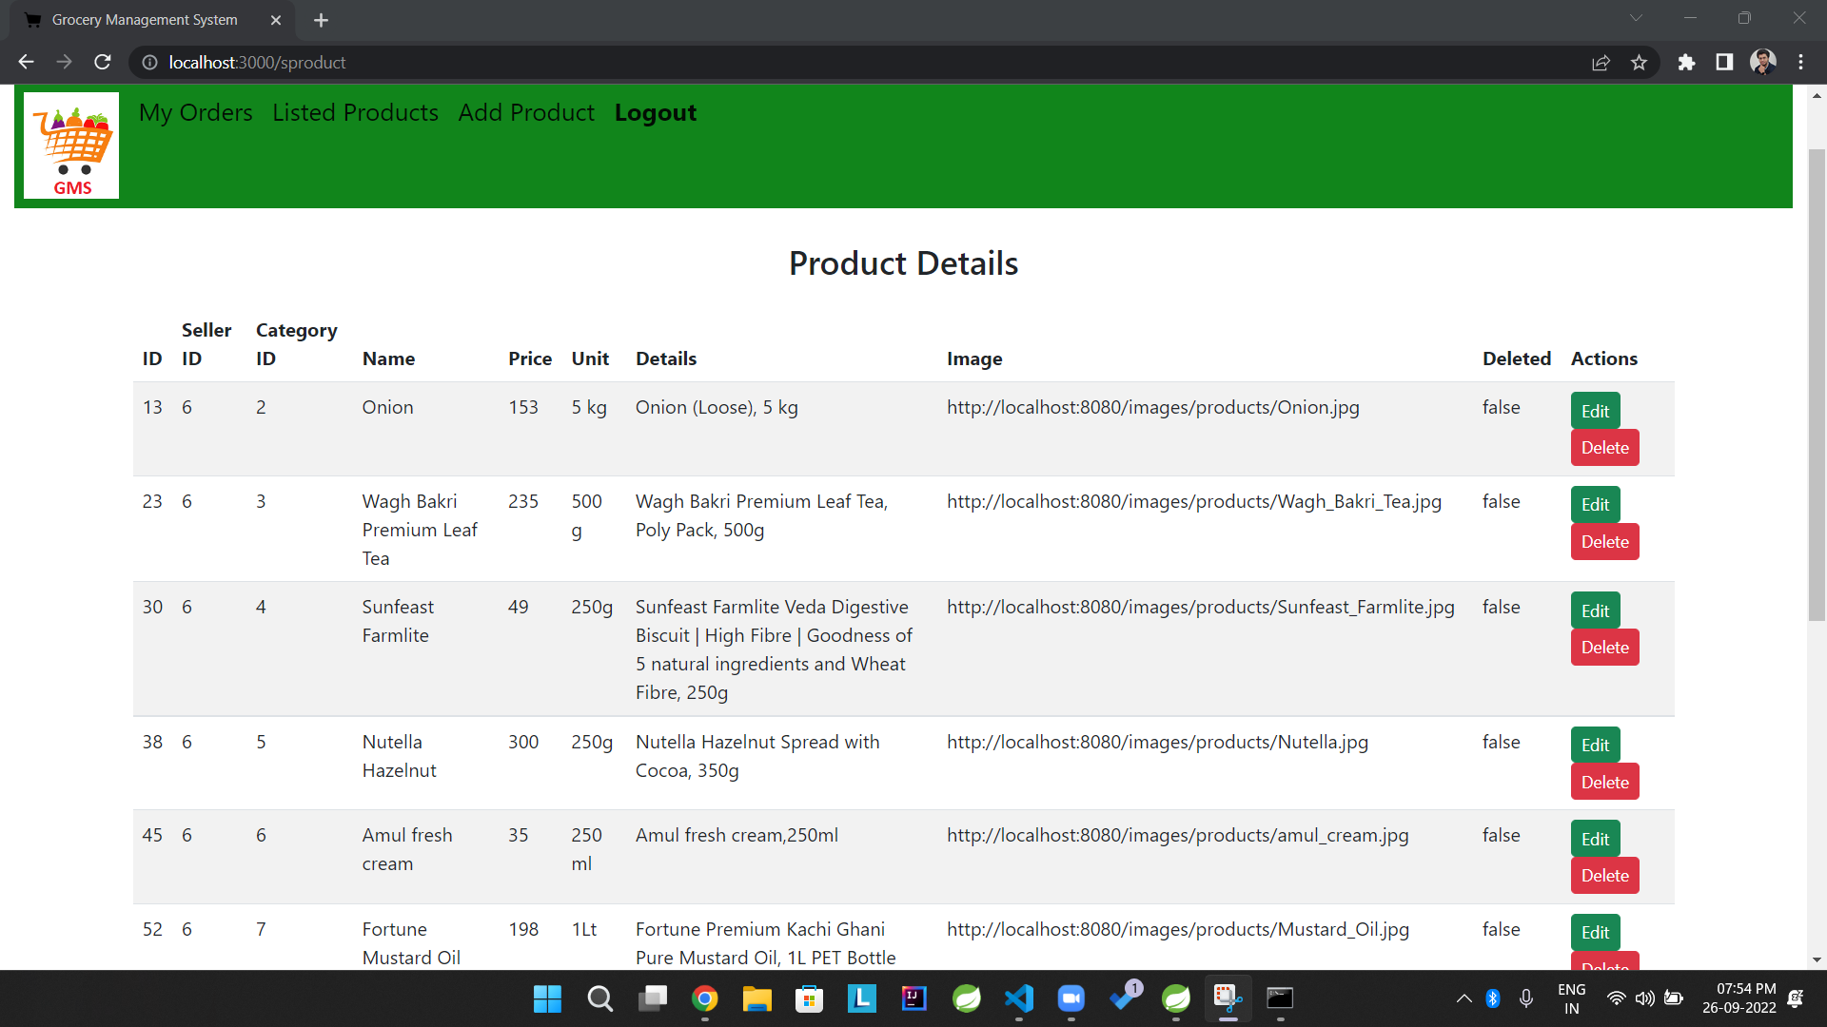

**Seller Page 🡪 Add Product:**

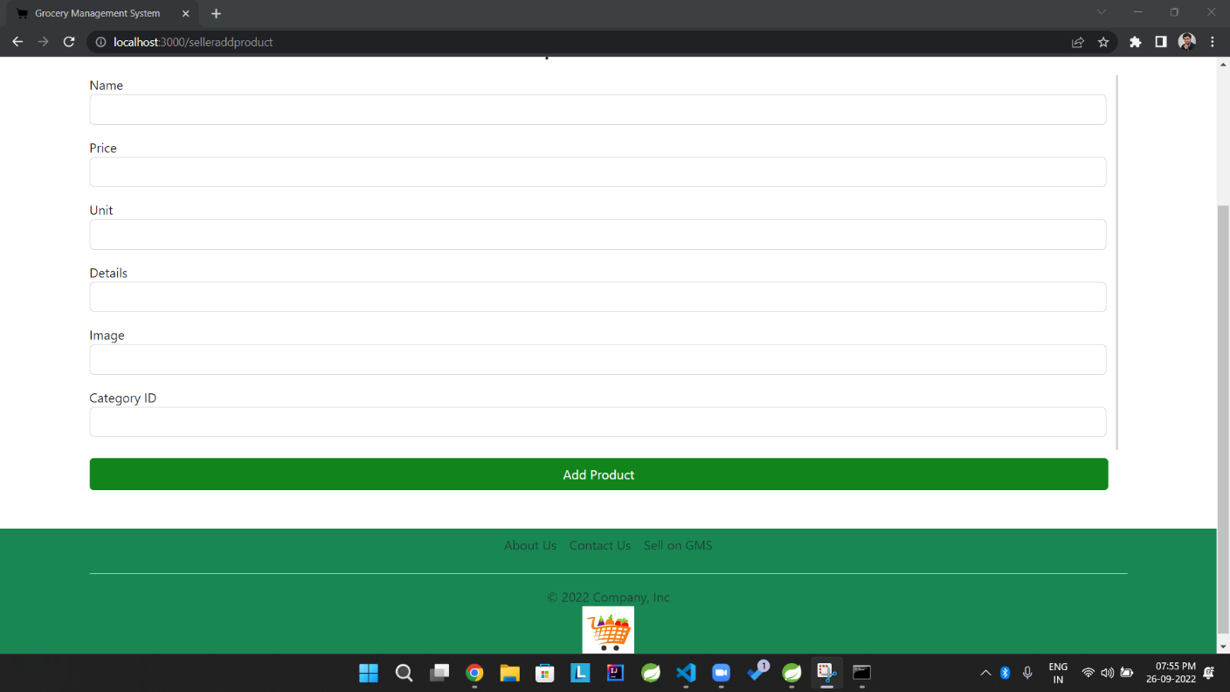

**Seller Page 🡪 Update Product:**

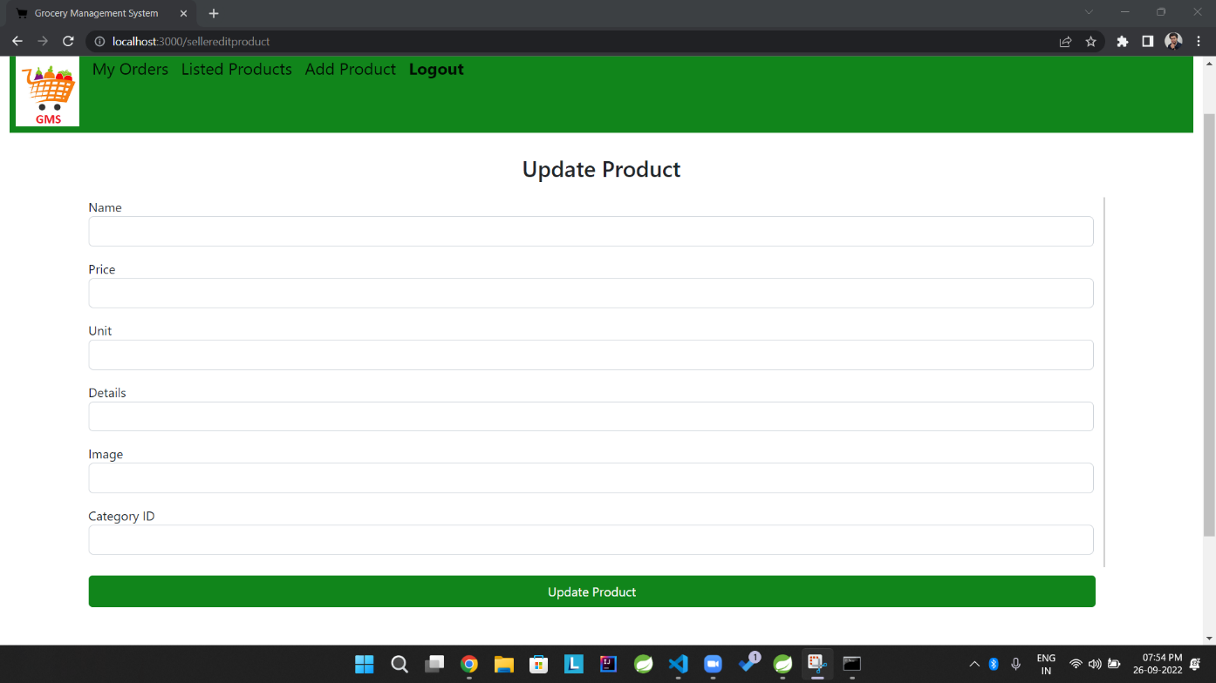

**7.REFERENCES:**

<http://www.google.com>

<https://www.amazon.in/>

<https://blinkit.com/>

<https://www.bigbasket.com/>

https://www.javatpoint.com/

http://www.w3school.org

<http://www.wikipedia.org>